**DAILY ONLINE ACTIVITIES SUMMARY**

|  |  |  |  |  |  |  |  |  |
| --- | --- | --- | --- | --- | --- | --- | --- | --- |
| **Date:** | **23/06/2020** | | | | | **Name:** | **NAIPUNYA VINOD NAIK** | |
| **Sem & Sec** | **IV SEM & A SECTION** | | | | | **USN:** | **4AL18CS050** | |
| **Online Test Summary** | | | | | | | | |
| **Subject** | | **N/A** | | | | | | |
| **Max. Marks** | | **N/A** | | **Score** | | | **N/A** | |
| **Certification Course Summary** | | | | | | | | |
| **Course** | **1) LIFERAY FOR BEGGINERS CREATE YOUR WEBSITE FOR BEGGINERS**  **2) THE INTERNET OF THINGS (IOT):2020 TRENDS AND THE FUTURE** | | | | | | | |
| **Certificate Provider** | | | **UDEMY** | | **Duration** | | | **1) 2.5 HRS**  **2) 41 MIN** |
| **Coding Challenges** | | | | | | | | |
| **Problem Statement:1)** [**Write a C Program to Sort a stack using a temporary stack**](https://github.com/orgs/alvas-education-foundation/teams/2nd-year/discussions/134)**.**  **2)** Write a [Python Program to Split the array and add the first part to the end There is a given an array and split it from a specified position, and move the first part of array add to the end.](https://github.com/orgs/alvas-education-foundation/teams/2nd-year/discussions/135) | | | | | | | | |
| **Status: EXECUTED** | | | | | | | | |
| **Uploaded the report in Github** | | | | | **YES** | | | |
| **If yes Repository name** | | | | | <https://github.com/naipunya-naik/lockdown-coding/tree/master/C%20CODING>  <https://github.com/naipunya-naik/lockdown-coding/blob/master/PYTHON%20CODING/SplitArray_23-06-2020.py> | | | |
| **Uploaded the report in slack** | | | | | **YES** | | | |

Online Test Details: (Attach the snapshot and briefly write the report for the same)

NO INTERNALS CONDUCTED

Certification Course Details: (Attach the snapshot and briefly write the report for the same).

CERTIFICATION COURSE NAME:- LIFERAY FOR BEGINNERS CREATE YOUR WEBSITE WITHOUT CODING.



CERTIFICATION COURSE NAME:- THE INTERNET OF THINGS (IOT):2020 TRENDS AND THE FUTURE



Coding Challenges Details: (Attach the snapshot and briefly write the report for the same).

PROBLEM STATEMENT 1:- [Write a C Program to Sort a stack using a temporary stack](https://github.com/orgs/alvas-education-foundation/teams/2nd-year/discussions/134)

Top of Form

Bottom of Form

|  |
| --- |
| We follow this algorithm.   1. Create a temporary stack say tmpStack. 2. While input stack is NOT empty do this: • Pop an element from input stack call it temp • while temporary stack is NOT empty and top of temporary stack is greater than temp, pop from temporary stack and push it to the input stack • push temp in temporary stack 3. The sorted numbers are in tmpStack   Screenshot (168).png |

GITHUB REPOSITORY LINK:-

<https://github.com/naipunya-naik/lockdown-coding/tree/master/C%20CODING>

PROBLEM STATEMENT 2:- Write a [Python Program to Split the array and add the first part to the end There is a given an array and split it from a specified position, and move the first part of array add to the end.](https://github.com/orgs/alvas-education-foundation/teams/2nd-year/discussions/135)

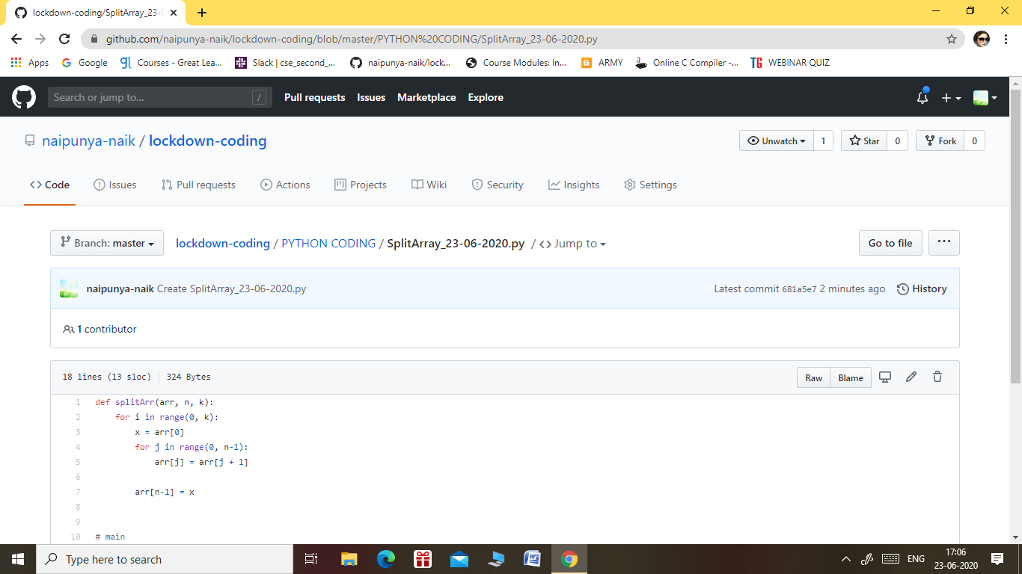

GITHUB REPOSITORY LINK:-

<https://github.com/naipunya-naik/lockdown-coding/blob/master/PYTHON%20CODING/SplitArray_23-06-2020.py>